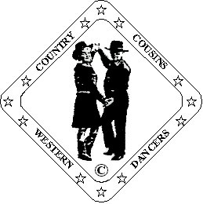
Ron & Ann Williams.
D & G Fully Qualified Instructors
B-W-D-A
023 9234 1758 ronannwilliams@ntlworld.com

Our Dream

Partner Dance (56 Count)

Choreographed By Ann Williams. “Country Cousins Western Dancers” 03/09
Music: “I Can Dream” By Stacy Dean Campbell. 112 bpm.
CD “Hurt City”

“Out Of Your Shoes” By Lorrie Morgan. 104 bpm.
CD “Leave The Light On”

Beats/Step Description.
Start man facing L.O.D. lady facing R.L.O.D. holding inside hands.
Same feet throughout.

Step. Pivot ½. Step. Pivot ¼. Cross Rock. Recover. ¼ Turn Shuffle.
1-4 Step right forward. Pivot ½ turn left. Step right forward. Pivot ¼ turn left.
Release hands.
5-8 Step and cross rock right over left. Recover onto left. Turn ¼ right and shuffle forward.
Touch right palms on cross rocks. Man now facing R.L.O.D. Lady facing L.O.D.

Step. Pivot ½. Step. Pivot ¼. Cross Rock. Recover. ¼ Turn Shuffle.
9-12 Step left forward. Pivot ½ turn right. Step left forward. Pivot ¼ turn right.
13-16 Step and cross rock left over right. Recover onto right. Turn ¼ left and shuffle forward.
Touch left palms on cross rocks. Join inside hands after turn shuffle.
Man now facing L.O.D. Lady facing R.L.O.D.

Rock. Recover. (Lady Step. Pivot) Shuffle. Walk. Walk. (lady Full Turn) Shuffle.
17-20 Man: Step and rock back on right. Recover onto left. Right shuffle forward.
Lady: Step right forward. Pivot ½ turn left. Right shuffle forward.
Raise right hands for ladys pivot and keep raised for her full turn.
21-24 Man: Walk forward on left, right. Left shuffle forward.
Lady: Step onto left, right making a full turn right. Left shuffle forward.
Rejoin left hands in Right Side by Side position. Sweetheart.

Changing Sides.
25-28 Man: Step right to right side. Turn ¼ left stepping onto left. Step right back turning ¼ left.
Step left slightly back..
Lady: Step and cross right over left. Turn ¼ right and step left back. Turn ¼ right stepping right forward.
Step left slightly forward.
Raise left hands over ladys’ head, lower right to end with hands crossed in front facing R.L.O.D.
29-32 Man: Step right to right side. Turn ¼ left stepping onto left. Step right back turning ¼ left.
Step left slightly forward.
Lady: Step and cross right over left. Turn ¼ right and step left back. Turn ¼ right stepping right forward.
Step left slightly forward.
Release right hands, raise left over ladys’ head, rejoin left in Right Side by Side position facing L.O.D.

Shuffle. Shuffle.
33-36 Right shuffle forward, Left shuffle forward.

¼ Turn Rock. Recover. Back. Cross Over. Side. Cross Behind. ¼ Turn Shuffle.
37-44 Turn ¼ left and rock forward on right. Recover onto left.
Release left hands, raise right over ladys’ head and lower, rejoin left in Reverse Indian position.
Step right back. Step and cross left over right. Step right to right side. Step and cross left behind right.
Turn ¼ right and right shuffle forward.
Release left hands, raise right over ladys’ head. Keep raised for next move.

Rock. Recover. (Lady Step. Pivot) Shuffle.
45-48 Man: Step and rock forward on left. Recover onto right. Triple step in place on left, right, left.
Lady: Step left forward. Pivot ½ turn right. Triple step in place on left, right, left.
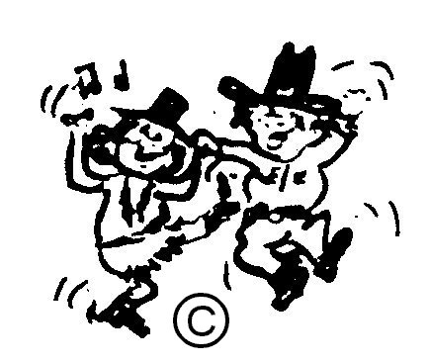
Lower right hands into inside hand hold.

Pinwheel ½ Turn Right: Walk. Walk. Shuffle. X 2.
49-52 Making ½ turn right, walk forward on right, left, right shuffle.
53-56 Making ½ turn right walk forward on left, right, left shuffle.
Now back into start position.

HAPPY DANCING

